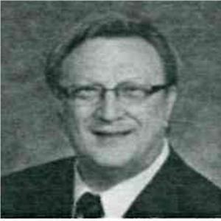
Dr. Robert Pasch
Why Holding Appliances (Phase 1 Treatment) Work
Codes: 117; Other
CE Hours: ?

This presentation will focus on the effectiveness of Holding appliances, their timing criteria and their failures. Successful uses of these appliances will be shown…

Holding arches are used to preserve arch perimeter so permanent teeth have enough room to
erupt, allow forward facial development, and may potentially prevent upper canine impactions,
or aid in de-impactions. Presentation and discussions of clinical studies and MS submissions,
targeting Arch Perimeter length changes going from Mixed to Permanent Dentition, and how
we can manipulate length to the benefit of the dentition and face.

Holding Appliances allow the practitioner with an eye to the future, significant freedom to guide
development of the entire oral environment. These freedoms will be discussed showing clinical
cases. The practitioner using these appliances will have the ability to guide the developing
dentition forward, so to minimize the need for extractions and develop aesthetic faces.

Holding appliances allow the dental arches to develop according to their patient specific
genetic coding, they preserve facial development according to the patients phenotype, and by
examining the overall orofacial system before the appliances are planned, crossbites, airway
obstructions, sleep issues, improper swallow and other habits can be identified and corrected
so that Phase 1 treatment, (holding arches) will be non problematic for the patient, and
subsequent Phase 2; (Braces) will create an aesthetic face, beautiful smile, and stable
functional dentition, with proper lip support. clinical cases showing this will be presented.
Dr. Pasch graduated from the Faculty of Dentistry, University of Toronto in 1982 and
started a general dental practice in Mississauga Ontario immediately after graduation, his love of orthodontics compelled him to help out two classmates in their practices by
treating patients who were in need of orthodontics, this activity grew over the years to
where Dr Pasch now has treated over 8000+ patients to date, including some 200 cases
of Invisalign.

